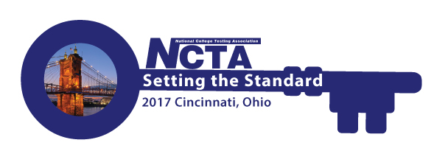
NCTA 2017 Annual Conference Committee Meeting
Monday, May 15, 2017
2:00 PM Eastern Time
GoToMeeting
https://global.gotomeeting.com/join/554423357

You can also dial in using your phone.
United States: +1 (646) 749-3112

Access Code: 554-423-357

Agenda

- Roll Call - Jody Atkins
- Committee Updates – Cindy James (chair)
    - Conference Planner Updates
    - Registration Report
    - Housing Report
    - Conference Marketing
  - Program – Bob Lang/Jim Wollack
    - Conference Agenda Update
    - Keynote Update
  - Virtual Conference – David Espinoza/Tremaine Williams
  - Sponsorship/Exhibits – Rosemary Freer
  - Resource Fair – Jamila Maxie
  - Host Committee – Paula Doughman
  - Conference App – Amystique Church
- Other/New Business
- Adjourn – Next meeting is Jun 19.

